Helmer LK 707

Flashlight & Camera User Manual
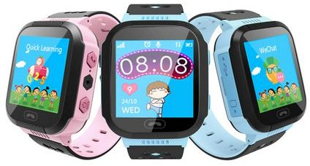

Please read the instruction before installing and using the watch. Product color in kind prevails!
- Before using
  - Check whether the watch is the purchased model and has complete accessories: 1GPS Watch with silicon wristband, 1 USB Cable,1 User manual.
  - Order a Micro SIM card which supports GSM network (2G). SIM card need enable GPRS data and caller ID function, 30 MB data per month will be enough.
  - Turn off the watch before installing the SIM card.
  - Charge the battery by connecting to a computer with the matched USB cable. Do not charge over 3 hours.
Note: Charging the battery should only be under adult supervision.

  - Please scan the barcode of this manual last page to download the APP Setracker on your phone.

Watch interface

Answer key

Flashlight

Power button/SOS on-hook
Camera

USB slot SIM card slot

Answer Key Return key

This picture is just for reference.

2.1 Product function
- GPS+LBS real-time Positioning
- Make friends between watches
- 1.44 inch IPS Touch color screen
- Flashlight and camera
- Records of step, distance
- Remote silent shot monitoring
- Footprints: record history route

- Voice monitoring: Once the phone number confirmed, watch will call the number automatically while user don’t know.
- Two-way phone call and voice chat
- App available on IOS and Android Platform
- Setting no disturbing time when kids on class
- GEO fence safety area
- SOS Phone call and alert
- low power alarm
- Remote shutdown

Watch function interface
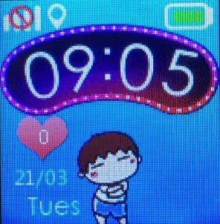
  - Main interface: small icons on the interface top left to right represents: GSM signal, location, power, the following is the time, number of love, week, date.

  - Phone call interface: calling can be answered by touching screen virtual buttons and on hook by pressing power button.

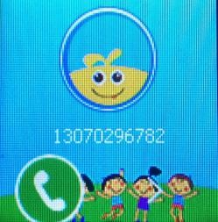
***

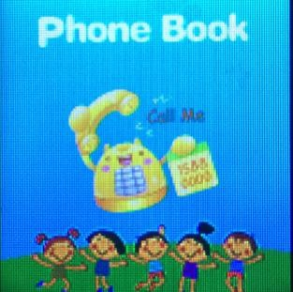
  - Phone book: click and enter to set 10 phone numbers by app, and pick number to dial.

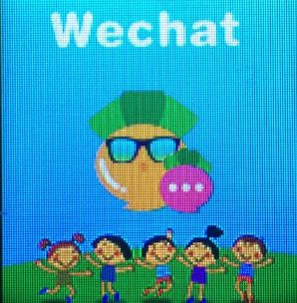
  - Wechat: click the screen and you can see the chat interface, the button “press” to recording voice message and released to send to mobile phones, the longest voice message is 15 seconds.

  - Flashlight: click the switch and the light of the right side of the watch will be turn on.

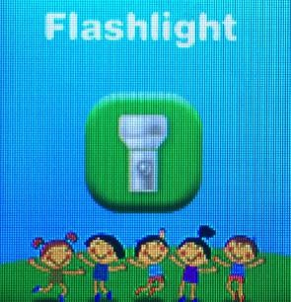

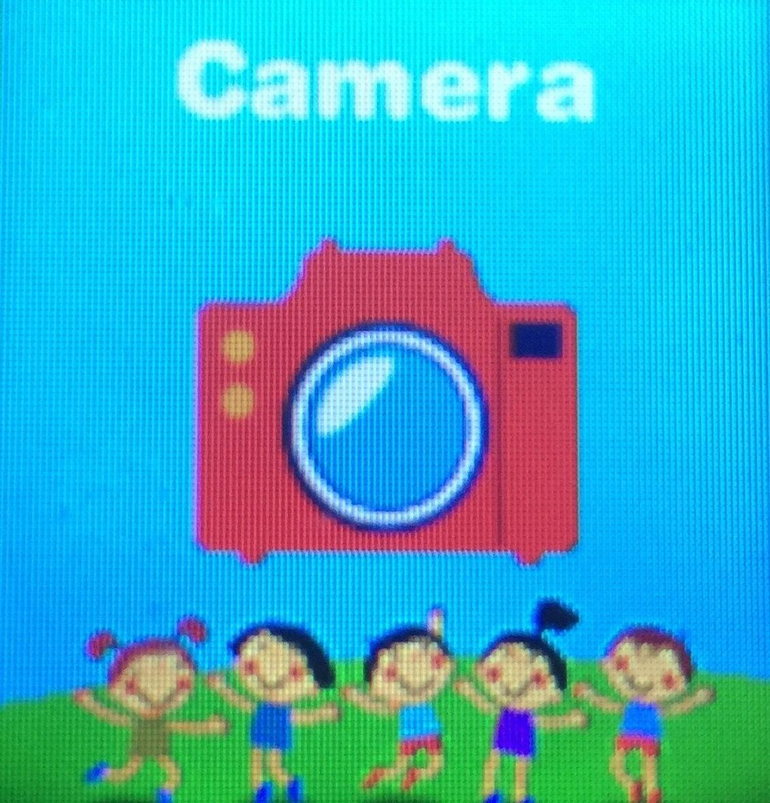
  - Camera: shot to store the bright moment.Also support remote silent shot by APP.

  - Album:Check the picture in here.The picture which remote silent shot is store in the APP.

  - Touch make friends: With 2 watches support make multiple friends (or 2 watches support make single friend)and have same time and connect the network, get touch the screen then both watch will

add each other.

  - Step: Pedometer is off by default, function can be turned on in the App. When pedometer is working, number of steps will sync.
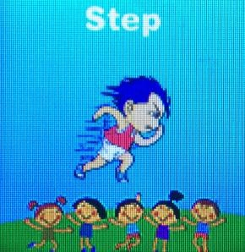
  - Scanning: Click the QR code of the app, the icon of QR code magnifies, use the phone to scan the code, then you can download the APP. The ID shown below is the ID number of the watch.

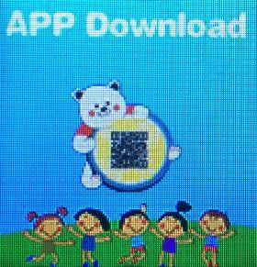

  - quick learning: with 3 level math test.
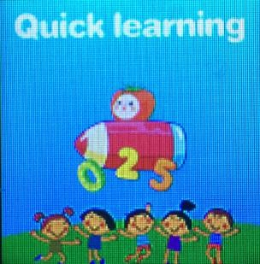

Set up watch with App
  - APP Registration and login
App only available on IOS and Android , Windows do not support. Search ”Setracker” on App store and Google play or scan the bar code of the last page manual to download and enter the following page shown on the pic1.
Fill into the unique ID of the watch(by scanning the QR code or entering the ID manually) and unique user name (at least 4 characters, whether letter or number) before login, the P-number is parents’ number, then set the password (at least 6 characters),at last select the server location which your country belongs to.

The login interface is shown as below: pic2
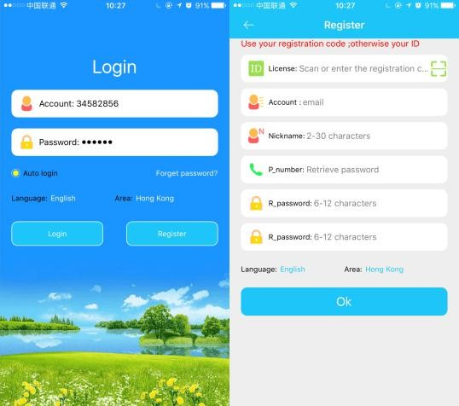

  - Introduction of APP main interface
Enter the correct account and password on the login interface, click to login and enter the main interface. The main interface is shown as below:

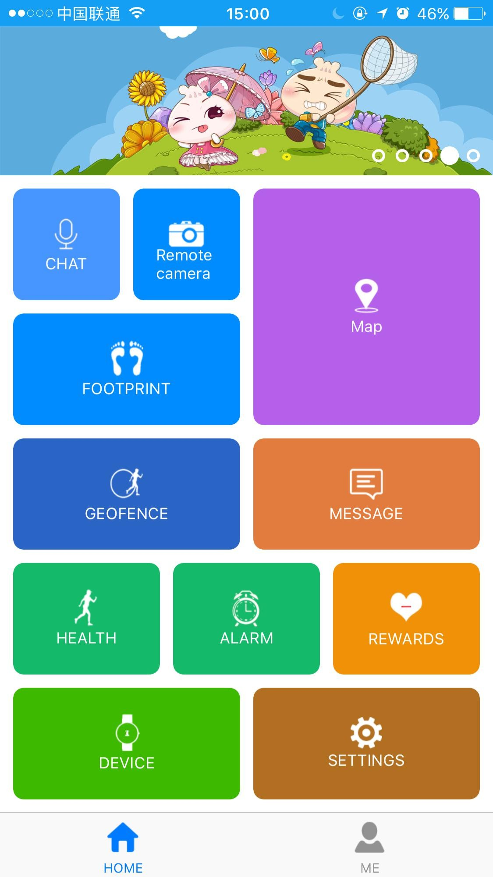

Description of functions:
- Voice chat: Click “Long press and speak” to start recording. Release the button to send the message. The longest voice message can be 15 seconds.
- Map: Check the position of the watch in real time. Each positioning working time is 3 minutes. The interval time for location data updating need 20 seconds. After 3 minutes, device will back to the default working mode. You can know the real-time location in the map.
- Camera:parents can remote monitor the kids by silent shooting while kids don’t know, the picture will shown on APP after 5 seconds.

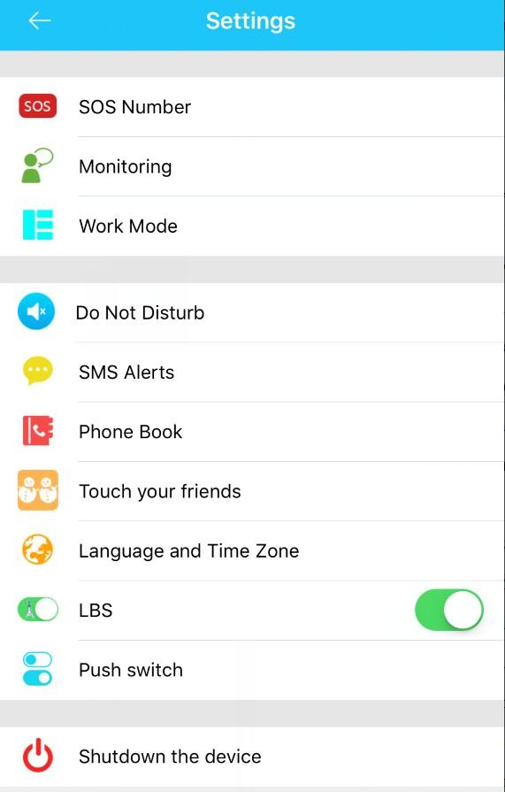
- Settings: you can set all parameters of the watch, settings interface shown as below:

- SOS number: three numbers can be set up, the watch will calling to the phone automatically by pressing the watch SOS button for 3 seconds in case of an emergency, and there will have alert message sent to APP. Three phone numbers will be called one after another twice (unless the call is answered).
- Monitoring: generally parents' phone numbers are set as monitor number. Once the phone number confirmed, the watch will call the monitoring number automatically, please do not make any sound then you will hear the sound around kids. But the watch cannot hear

the sound of mobile phone.
- Synchronization intervals: three models can be chosen according to customer's requirements, the default working mode is every 10 minutes; power saving mode to update location is every 1 hour, and the real-time positioning mode is 1 minute.
- No disturbing time: you can set three periods, all incoming calls will be shielded during three periods, watch lock only SOS calling work,this function is suitable for kids on class. Class mode only works from Monday to Friday, weekends are excluded.
- Notification settings: with low power, SOS alert switches. If the power less than 20% and press SOS button over 3 minutes, alert shown on the watch (default off), at the same time send SOS alert to phone.
- Phone book: There are 10 numbers can be added and the number and name display on watch,these number be allowed to call the watch and vice versa.
- Touch your friends: with 2 LK 707 watches installed with the same SIM card operating company, get touch then both phone numbers will be added in the Contact of App.
- Language and Region: If the time display on the watch is not correct, you can choose the time zone to fix. But this function only works when the watch is connecting to the APP.

- LBS: Click the switch and open the base station positioning.
- Remote shutdown: Watch cannot be shut down by pressing button after it starts to work, but it can be turn off from APP.
- GEO fence safety area: it’s minimum radius is 200 meters, when users go in and out of the fence, there will has alarm information when kids out of the fence.
Note: fence alarm information only when the watch GPS is triggered, base station (LBS)positioning fence has no alarm information.
- Love rewards: select the number of red hearts on the app, click the number send to watch, then watch screen will display the number of love heart.
- Watch alarm: can be set up three alarm clocks, and alarm clock can be set according to requirements.
- Device: it is to search the watch, when watch is not around, click this function key the watch will ring for a minute unless press any key to stop.
- Footprint: This function is used to check the history route of kids in different period. The location data can be saved up to 90 days. (10)Display activities: you can see the records of step count, amount of exercise, distance and sleep monitor.
(11)Notification overview: you can see the earlier notifications.

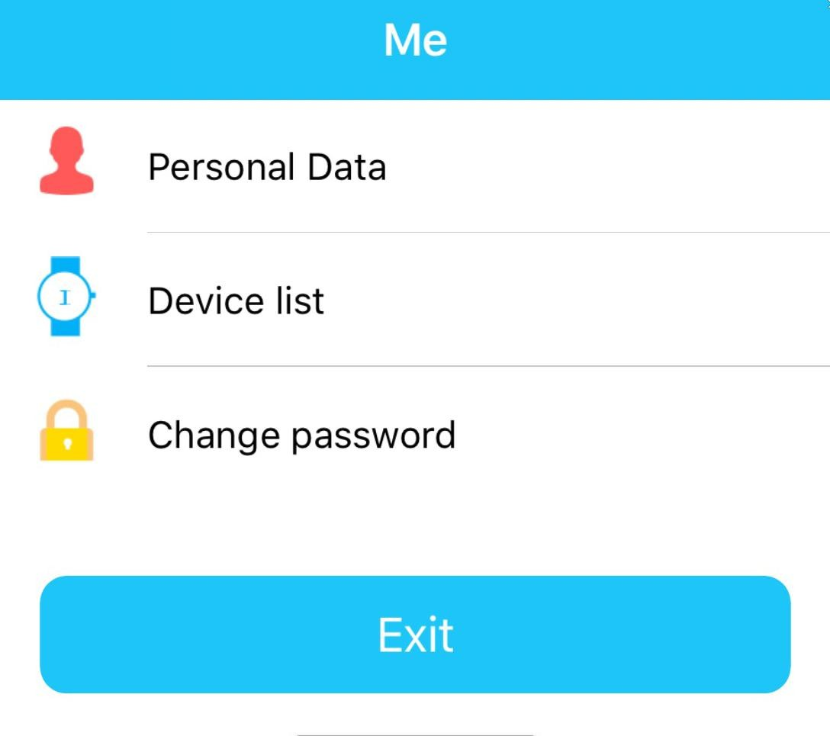
- "My" interface :Click left side “My” function key at main page and the page shown as below:

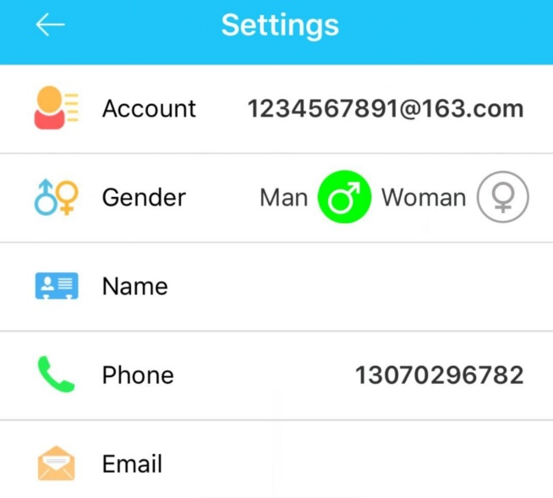
- On the personal data, you can see the account, ID and phone number. We suggest you fill the email address.
**

- The device list: If you have more than one device to monitor, then you can add them in one account. Please notice, you just need register one watch then add IDs of other watches here.

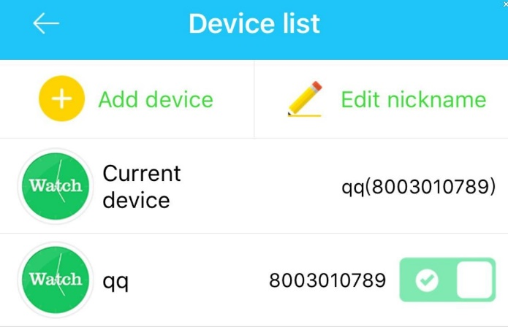
***
**

- “Change the password” function.
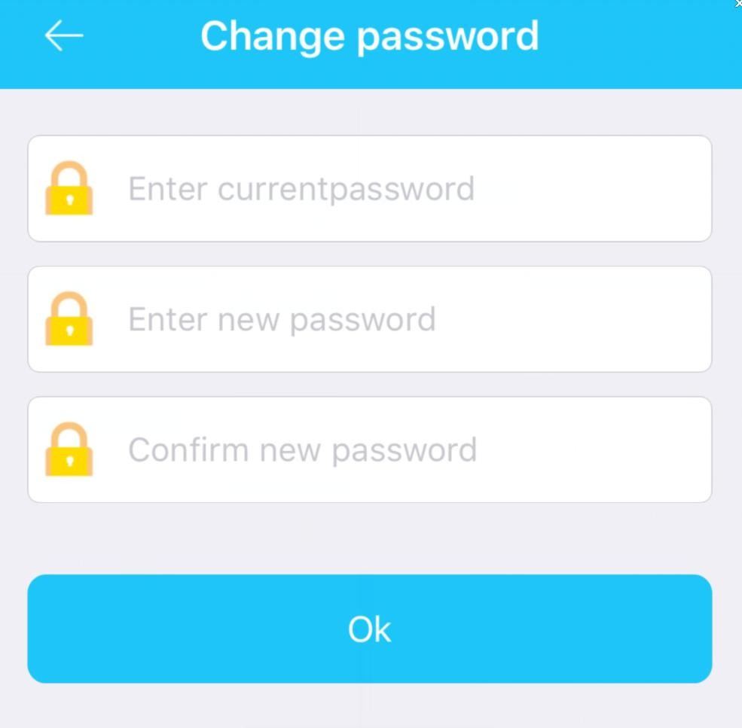

Working mode of the watch
Three basic working modes include normal mode, power saving mode and real-time positioning mode. Upload interval is different on different working modes.
Normal mode: upload interval is 10 minutes; Power saving mode: upload interval is 1 hour; Real-time positioning: upload interval is 1 minute.

Troubleshooting
- Can not register an account
An error when entering ID (does not exist or is already registered). Please contact us directly to resolve the issue on servis@prijimace.cz and we will provide you with all the necessary technical supports.
- The device is not connected to the Internet.
- Check whether your SIM card supports 2G network, for example Telecom is not supportive, and data consumption fee inside.
-Use mobile phone text message to the watch: pw,123456,ts#,in response you will receive SMS message with the specifications, please contact us for support, then we immediately find the cause and solution.

8. Download the APP

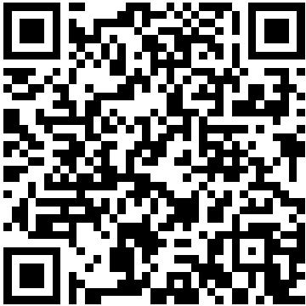

Support Android or IOS mobile phone APP: Setracker

Note: The company reserves the right to modify the instruction contents without any further notice, please understand no further notice about the modification. Part of the function is different in particular software version, but is normal.

