Kids Smart Watch User Manual
Please read the instruction manual carefully before use, so that the correct installation and rapid use。The color is subject to the actual product.
Ⅰ、Preparation before use
Confirm the model is correct, accessories are complete.
Select the SIM card of GSM network and refer to the dealer's opinion.（Shut down before inserting the card）
Ⅱ、Watch instruction
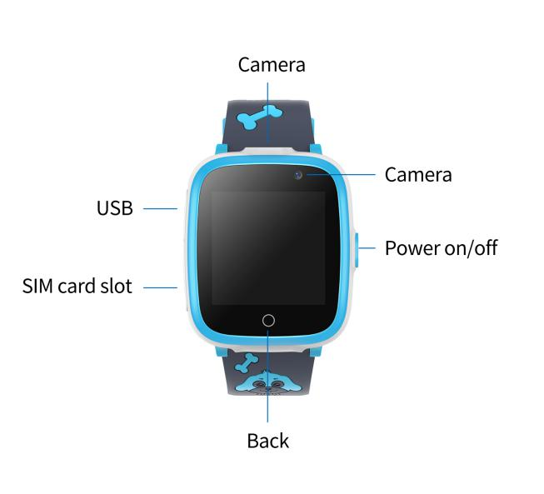

Touch operation instructions: Swipe left and right to switch the standby screen, click to enter the main menu.
2.1 Power On/Off
Power On: Press and hold the power button
Shutdown: Press and hold the power button
* If the device fails to turn on, this could be caused by low battery. Please try again after recharging the device for 5 minutes.
2.2 Charging
Remove the silicone plug on the USB charging port, and then connect the Micro-USB end of the cable to the watch and the other end to the USB charger.
*After the charger is plugged to the power socket, the power icon at the top right of the screen will start scrolling, indicating that it is in charging mode. The power icon will stop scrolling with a full battery icon when fully charged.

suggest to use 5V 1A charger
Note: Do not use an adapter with a rated output voltage exceeding 5V to avoid damage to the device.
2.3 Install a SIM card
Insert the SIM card into the card slot as prompted by the direction (chip facing up, beveled angle facing in) of the symbol.（Install the SIM card when the device Power off）
*The SIM card must support the GSM network, otherwise the communication function is invalid!
Ⅲ、Main interface and function instruction
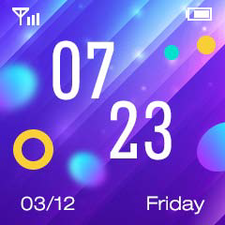
Battery capacity
signal
Time

week
date

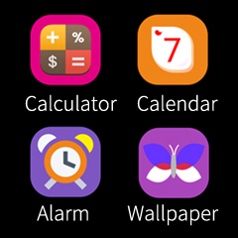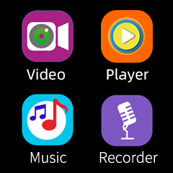
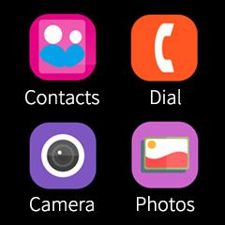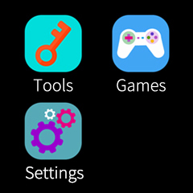

3.1 Contacts
click on the standby interface to enter the main menu，select the Contacts and click to enter，you can choose dad，mun or others respectively，click set number to enter the interface，after editing，click save.tap the avatar on the phone book record interface to make the corresponding call.
Note：The phone book can save 10 numbers.
3.2 Dial
In the main menu, select Dial and click to enter. After entering the number on the dial pad interface, press the dial button to call out the call directly.
3.3 Camera
Select the Camera in the main menu and click to enter the preview interface, click the middle button to take a picture, click the conversion button in the upper left corner to switch the camera, and click the back button to return.
3.4 Photos
Select Photos in the main menu and click enter to view the saved photos.
3.5 Video
Select the Video in the main menu and click to enter, click the camera icon in the lower left corner to start recording, and click the return icon to end the recording and save. Click the camera icon in the upper left corner to switch between front and rear cameras.
3.6 Player
Select Player in the main menu, click to enter, select video to play.
3.7 Music
Select Music Player in the main menu and click to play music.
Note: You need to copy the song to the My Music folder of the watch first.
3.8 Recorder
Select Recorder in the main menu and click to enter, you can record.
3.9 Calculator
Select the calculator in the main menu and click to enter, you can use a simple calculator to perform calculations.
3.10 Calendar
Select Calendar in the main menu and click to enter, you can view the calendar.
3.11 Alarm clock
Select the alarm in the main menu and click to enter, you can set the alarm, up to three different alarms are supported. The switch can be set to select the time and period.
3.12 Wallpaper
Select the wallpaper in the main menu and click to enter, you can set the background wallpaper of the main menu.
3.13 Tools
In the main menu, select the tool and click to enter. There is a menu for stopwatch / timer / file management.
3.14 Games
In the main menu, select the game and click to enter. There are 6 puzzle games were built in the watch..
3.15 Setting
◆Language
Multi - language
◆Time/date
Can set time and date
◆Calling record
Can check
◆Silent mode
The watch will be in silent mode when turned on
◆Parent control
①Long press the screen until enter the parental control settings.
②According to the prompt, click the corresponding color area three times, to unlock and enter the parental control setting interface.
③Daily game time can be set to: no play, 15 minutes, 30 minutes, 60 minutes, 90 minutes, unlimited.
◆ Reset
After selection, the factory settings can be restored
Ⅳ、FAQ

Q: What type of SIM card is suitable for this watch?
A: The watch only supports the SIM card with 2G GSM communication standard. To make a phone call, the voice call service of the SIM card must be enabled. Please contact local communication operator for details.

Q: Can I use the watch without a SIM card?
A: If the watch does not have a SIM card, the communication-related functions will be disabled, such as call.

Q: What are the requirements for the charger?
A: Please use a USB charger for the watch. It is recommended to use a mobile phone charger 5V 1A .
Attention： Avoid to use the charger over 5V output,escape from being bad for device.

Q: How long does it take to fully charge the watch?
A: It might take about 2-3 hours to charge the watch. There is a power icon on the watch which indicates the current power. When the power is low, please charge it immediately.

Q: Can't power on.
A: The power of the battery will drain completely if watch will not be used for a long time. Before using it again, charge the device for 10 minutes first.

