GSM/GPRS/GPS Portable Tracker
User Manual

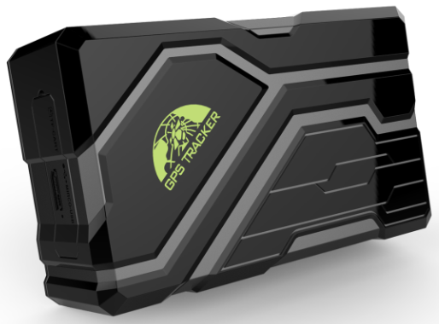

In order to protect the environment and provide timely up-to-date information about your tracker, we have made electronic user manual.
To download your electronic user manual, please visit our website:www.baanooliot.com

Contents
1. Specifications 3
2. Hardware Description 3
3. Quick Charger 4
4. Installation (Model B) 4
5. Insert SIM card, turn on the device 5
6. Device Status Light 6
7. Mobile APP 6
8. BAANOOL IOT’s Web Version 7
9. GPRS configuration for live real-time tracking 8
9.1 APN Setting 8
9.2 Configure user name and password of GPRS 8
9.3 Configure domain name and port 9
9.4 GPRS mode 9
10. Function Details 9
10.1 Changing Password 9
10.2 Authorization 10
10.3 Single Tracking 10
10.4 Sleep tracking strategy 11
10.5 Smart angle updating 13
10.6 GPS drift suppression 14
10.7 Location based service (LBS) / Cell-ID tracking 14
10.8 Listen 14
10.9 Forwarding incoming SMS messages 15
10.10 SIM Card Balance Enquiry 15
10.11 Remote immobilizing (Model B) 15
10.12 Configure times of alarm 16
10.13 Alarms 16
10.14 Check Status 18
10.15 Check IMEI 18
10.16 Local time setting 18
10.17 Reset Hardware 19
10.18 Configure parameters by USB 19
10.19 TCP / UDP switch 19
10.20 SMS mode 19
10.21 Configure SMS monitoring center number 19
10.22 Configure GPRS heartbeat package interval 20
10.23 Initialization 20
11. Cautions 20
12. Troubleshooting 21

Specifications
Product name | Wireless data terminal
Model | 108
DIM. | 106mm * 63mm * 37.5mm
Weight | 343g
Network | GSM/GPRS
Band | 850/900/1800/1900Mhz
GPS sensitivity | -165dBm
GPS accuracy | 5m
Time To First Fix | Cold status 45s  Warm status 35s  Hot status 1s
Battery | Chargeable 3.7V 10000mAh Li-ion battery
Storage Temp. | -40°C to +85°C
Operation Temp. | -20°C to +65°C
Humidity | 5%--95% non-condensing
Waterproof Grade | IP67

Hardware Description
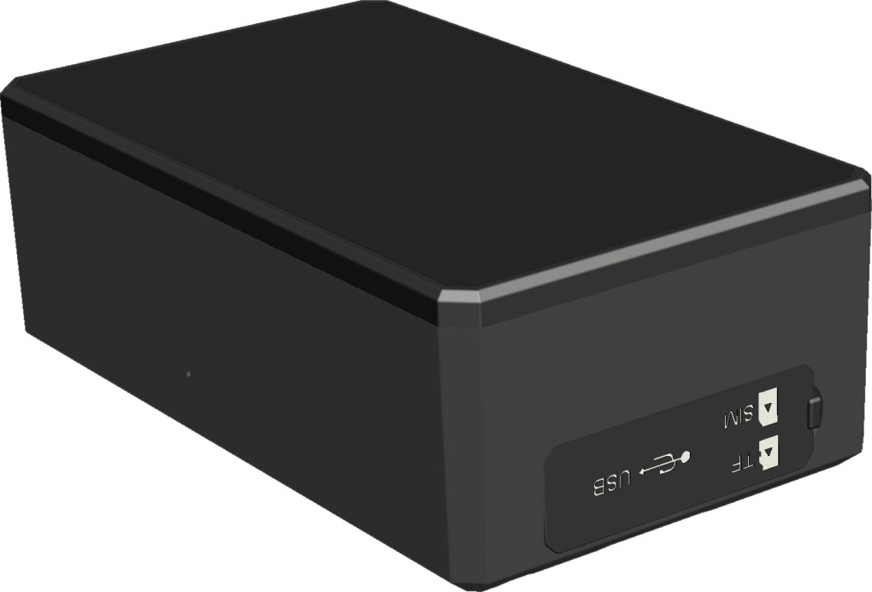
❶
❷
❸
❺

❹
❶ USB port ❷ TF card slot ❸ SIM card slot
❹ Microphone ❺ Rear cover of magnet

Quick Charger
This device supports maximum 2A current quick charger.
Charger way: Connect the device to the AC adapter (Output voltage: 5V, current:2A) with the original MICRO USB cable.
Warning: Please use the original USB cable to charge, if the original USB cable is lost, the replacement USB cable is required to carry at least 2.5A and above.
Please use the manufacturer’s original charger and battery; the charge time of the battery is about 7-9 hours.
Warning: Lithium batteries contain harmful chemical constituents and may explode, please do not slam, stab or put into the fire.

Installation (Model B)
If you need to connect the external power, stop the engine and SOS function, please find the 4 PIN connector wire (optional accessories) to connect it as following diagram:
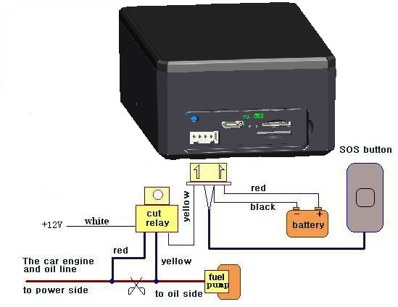
Note: Please install SOS button on the hidden place driver can touch.

Insert SIM card, turn on the device
Attention: Please be sure to open the voice call function, caller display function and data flow function, and PIN code is off, no call forwarding function. The recommended data flow package is not less than 30MB per month.
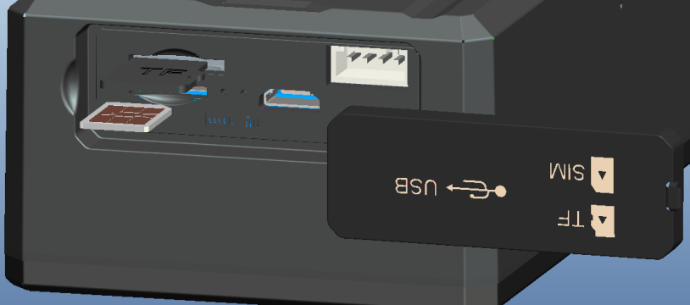
❷ Insert TF card as the picture shows.
❸ Insert SIM Card as the picture shows, and tracker will be turned on.

❶ Open the soft glue plug.

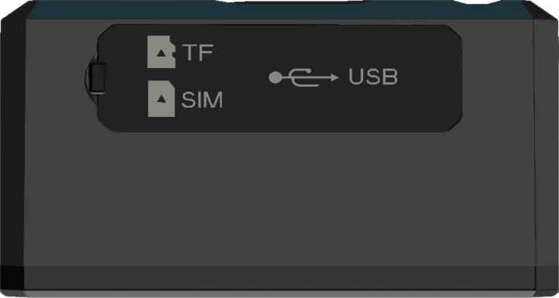
❹ Cover the soft glue plug

The device automatically turns on after inserting the card. Please bring the device outdoors for the first time to wait for about 10-40 seconds to search for GSM and GPS signals to start work normally.

Device Status Light
Indicators | Status
Power LED (Red) | Flash | Low battery
 | ON | Charging
 | OFF | Fully charged
GSM LED (Green) | ON | No GSM signal
 | Flash 1 time each second | GSM mode
 | Flash 2 times each second | GSM mode, GPS fixed
 | Flash 3 times each second | GSM mode, GPS signal is very good
 | Flash slowly 1 time each 3 seconds | GPRS mode
 | Flash slowly 2 times each 3 seconds | GPRS mode, GPS fixed
 | Flash slowly 3 times each 3 seconds | GPRS mode, GPS signal is very good

Mobile APP
Scan the QR code to download APP
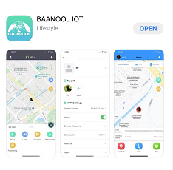
Google Play、App Store、Baidu App Store search “BAANOOL IOT” to download it
Register
Open BAANOOL IOT, register a new account and login, Choose “BAANOOL car “to enter it.

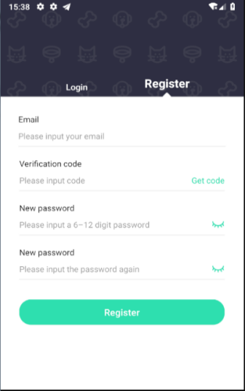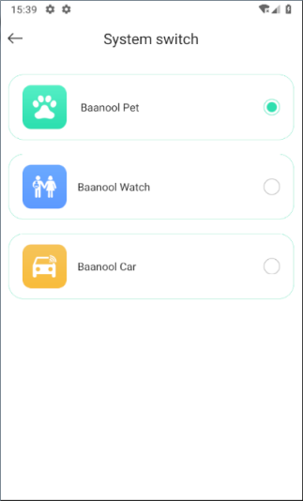
Bind Device
Click “Me”→ “Device Management”→ “Add”, scan the QR CODE on the device or enter
the IMEI manually to bind the device

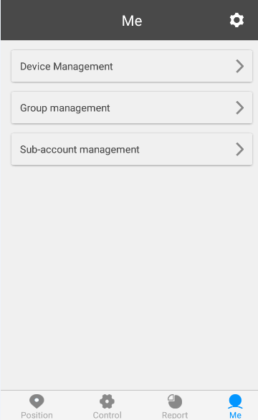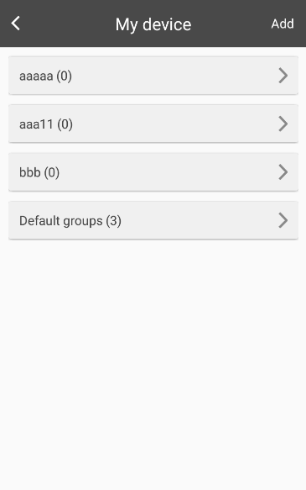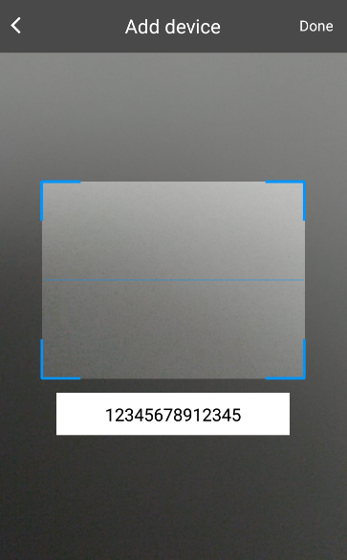
Scan QR CODE or enter the IMEI number
Click to add the device

点击添加设备

BAANOOL IOT’s Web Version
Open www.baanooliot.com , The login account name and password are the same as phone app’s
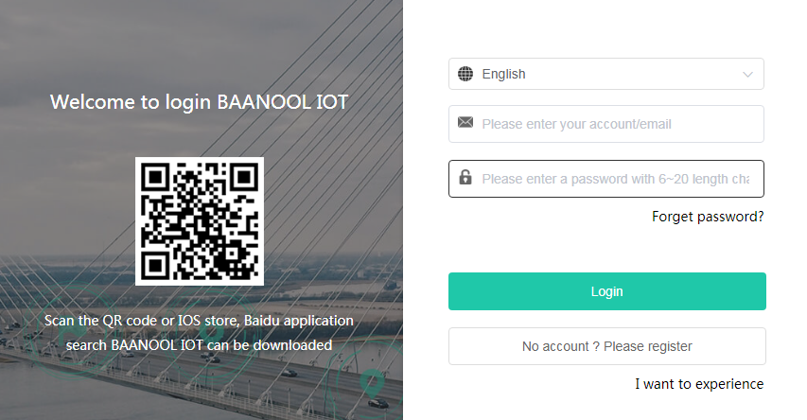

Attention：
When reading this user manual, you will notice that we have used "+" and "space"
between some words;"+" between two words means they should be written
together as one word and "space" between two words means you should leave one
character space between two words.

GPRS configuration for live real-time tracking
Set APN, Account user name and password to login web platform
Usually, the device can automatically recognize and select the APN, user name and password of GPRS settings. If the device cannot connect to the web platform, then you need to use the mobile phone text message to configure the settings according to following steps.

APN Setting
APN is an abbreviation for Access Point Name and changes depending on
which mobile network you are using. For more information about your local
APN, please check with your local wireless carrier.
SMS command: APN+password+space+local APN
Tracker response: APN OK
Example: APN123456 CMNET
Note: 123456 is the default password, please change password on APP or
refers to 10.1.

Configure user name and password of GPRS
In the most countries, the user name and password of GPRS are not necessary;
therefore, you can ignore this step if it is not necessary for your local network.
For those countries requiring user name and password, please configure as
following:
SMS command: up+password+space+user+space+password
Tracker response: user, password ok!
Example: up123456 Jonnes 666666
Note: 123456 means the password of the device, Jonnes means the user name
ofgprs, and 666666 means password of gprs

Configure domain name and port
Tracker connects to tracker.baanooliot.com 8090 by default. If you need to connect to another domain name, please configure it.
SMS command: dns+password+space+DNS domain name+space+port
Tracker response: dns success!
Example : dns123456 tracker.baanooliot.com 8090
Note:
If you want to configure IP instead of DNS, then please send SMS command: “adminip+password+space+IP+space+port”

GPRS mode
SMS command: GPRS+password
Tracker response: GPRS OK! (It means it has been switched to GPRS mode.)

Function Details
The following setting functions can be set through the APP or web version

Changing Password
    - SMS command: password+oldpassword+space+new password
Tracker response: password OK
    - Be sure to keep the new password in mind, you have to flash the firmware to restore the initialized setting in case of losing the new password
    - Attention: Make sure the new password is in 6 digits Arabic numbers, otherwise the tracker cannot recognize it

Authorization
Up to 5 numbers can be authorized.
    - call the tracker 10 times in succession, the number will be authorize automatically as the first number and tracker response “add master ok”
    - SMS command: admin+password+space+mobile phone number ,
Tracker response: admin ok。
    - SMS command: noadmin+password+space+authorized number
Tracker response: noadmin ok
    - If you want to receive these kinds of notification alerts when the trackers moved to another country, you must put the country code before the phone number to authorize it in international format, If there is a “0” before your phone number, please remove the “0”, for example, admin123456 008613322221111, then 13322221111 had been configure to authorization number。

Single Tracking
    - If there aren’t any authorized numbers set-up, it will reply all calls with a location report; if there are authorized numbers set-up, then it will not respond when an unauthorized number calls it。
    - If you call it from authorized phone number, it will hang up and report a real-time location as below：
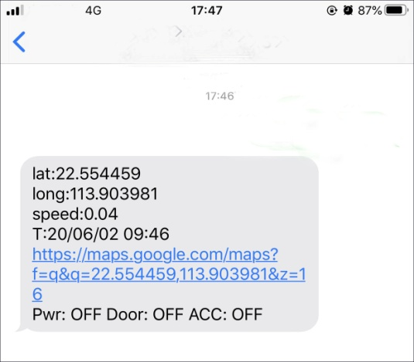
When it lost fix to satellites, the message will include the last known GPS position and a LAC code of the updated position as well。
    - SMS Command：position+password，The function is the same as 10.3.2

Sleep tracking strategy
Sleep Mode | Description | Application Occasions | Standby Time
Sleep by time | GSM module runs in low power consumption when sleep; Calling can wake it up, vibration cannot wake up, GPS module shuts down when motionless and no need to track in GPRS mode. | The target doesn’t need to be tracked frequently and can track it any time when necessary. | 10000*0.9 (Battery self-loss) /1.9mA/24h=197 DAYS
Sleep by shock | GSM module runs in low power consumption when sleep; vibration and calling can wake it up. | Sleep when it is motionless, and track when start to move | 10000*0.9 (Battery self-loss) /1.9mA/24h=197 DAYS
No sleep (Always online) | GPRS is always online, tracker will be intelligent to shuts down GPS module during the period which doesn’t need to track. | Real time tracking | 10000/31mA/24h=13.4 DAYS
Deepshock | GSM module shuts down when sleep; calling cannot be reached, vibration can wake it up. | Sleep if the target is motionless, and track when the target start to move | 10000*0.85(Battery self-loss) /0.3mA/24h/365d=3.2 YEARS
Deepschedule | GSM module shuts down when sleep; calling cannot be reached, but it will wake by itself to report its position according to the scheduled time | The target doesn’t need to be tracked frequently and let it report positions according to the schedules. | 10000*0.85 (Battery self-loss)/0.3mA/24h/365d=3.2 YEARS

    - Time sleep timing tracking strategy
SMS Command：Sleep+password+space+time+space+030m+001h+005n
The above command means: time sleep mode (If no operations in 3 minutes, GPRS offline and GPS off, any alarm trigger, call, sms can wake up), reported 30 minutes interval when the device is moving, and every 1 hour when it is stop , and only report 5 times, 005n means limited to 5 times of positioning, * **n means Unlimited times.
Time sleep mode is the default mode, but not default tracking strategy.
Note: The time must be represented by 3 Arabic numerals, the movement interval is at least 10 seconds, and the stop interval is at least 30 minutes (s: seconds, m: minutes, h: hours)
    - Shock sleep timing tracking strategy
SMS Command：Sleep+password+space+shock+space+030s+001h+005n
The above command means: shock sleep mode (GPRS offline when the device is stop, motion or any alarm trigger, call, sms can wake up), reported 30 seconds interval when the device is moving, and every 1 hour when it is stop , and only report 5 times, 005n means limited to 5 times of positioning, * **n means Unlimited times.
Note: The time must be represented by 3 Arabic numerals, the movement interval is at least 10 seconds, and the stop interval is at least 30 minutes (s: seconds, m: minutes, h: hours)
    - Shock sleep timing and distance tracking strategy
SMS command：Sleep+password+space+shock+space+001h+0200d +005n
command means：shock sleep mode (GPRS offline when the device stop, motion or any alarm trigger, call, sms can wake up)，report 1 hour interval when the device stop，When the device move, the moving distance reaches 200 meters, it will reported, and only report 5 times.005n is means limited to 5 times of positioning, * **n means Unlimited times.
Note: The time must be represented by 3 Arabic numerals, the distance must be represented by 4 Arabic numerals, d represents the distance, the distance unit is meters, and the minimum static interval is set to 30 minutes (s: seconds, m: minutes, h: hours)
    - Sleep off timing tracking strategy
SMS Command：Sleep+password+space+off+space+030s+030m +005n
The above command means: no sleep mode (GPRS is always online), It will update a position every 30s interval when moving，and update a position at 30 minutes interval when motionless, and only 5 times are updated, 005n means 5 times, ***n means unlimited times.
Note: The time must be represented by 3 Arabic numerals, and the time interval should be set to a minimum of 10 seconds (s: seconds, m: minutes, h: hours)
    - Sleep off timing and distance tracking strategy
SMS command：Sleep+password+space+off+space+030m +0200d +005n
The above command means: no sleep mode (GPRS is always online), It will update a position at 30min interval when moving, and update a position at 200 meters interval when motionless, and only 5 times are updated, 005n means 5 times, ***n means unlimited times.
Note: The time must be represented by 3 Arabic numerals, and the moving distance must be represented by 4 Arabic numerals. d represents the distance, the distance unit is meters, and the time interval is set to a minimum of 10 seconds (s: seconds, m: minutes, h: hours)
    - Deepshock sleep timing tracking strategy
SMS Command：Sleep+password+space+deepshock+space+010s+001h+005n
The above command means: deepshock sleep mode (GSM and GPS will be off when the device is stop, motion or any alarm trigger can wake up), reported 10 seconds interval when the device is moving, and every 1 hour when it is stop , and only report 5 times, 005n means limited to 5 times of positioning, * **n means Unlimited times.
Note: The time must be represented by 3 Arabic numerals, the movement interval is at least 10 seconds, and the stop interval is at least 30 minutes (s: seconds, m: minutes, h: hours)
    - Deepschedule sleep timing tracking strategy
SMS Command：Sleep+password+space+deepschedule+space+030m+001h+005n
The above command means: deepschedule sleep mode (If no operations in 3 minutes, GSM and GPS will be off, any alarm trigger can wake up), reported 30 minutes interval when the device is moving, and every 1 hour when it is stop , and only report 5 times, 005n means limited to 5 times of positioning, * **n means Unlimited times.
Note: The time must be represented by 3 Arabic numerals, the movement interval is at least 10 seconds, and the stop interval is at least 30 minutes (s: seconds, m: minutes, h: hours)
    - Cancel tracking strategy
SMS command：nofix+password，Tracker response: nofix ok

Smart angle updating
    - It will update positions automatically to web platform when the vehicle changes driving direction over a preset angle value to make its trace following the actual road and seem better on the map. This function is only available in GPRS mode.
    - SMS command: angle+password+space+angle value，Tracker response: angle ok
    - Note: The angle value must be 3 Arabic digits, and the default value is 30 degree.

GPS drift suppression
    - This function is deactivated by default.
SMS command to activate: suppress+password, Tracker response: suppress drift ok.
If you stop driving the vehicle, tracker will stop updating its position and keep sending the same latitude and longitude, and when start to driving, the latitude and longitude will update automatically again.
    - SMS command to deactivate: nosuppress+password, Tracker response: nosuppress ok

Location based service (LBS) / Cell-ID tracking
If the tracker cannot establish a solid GPS Fix, it will calculate its location using Cell-ID GSM locating. In SMS mode, location reports will include the GPS coordinates of the last known positions as well as a LAC code which is the current latest position. If in GPRS mode, tracker will automatically switch to tracking by LBS. and locate directly on the platform map with LBS positioning prompts. The base station positioning information has an error with the actual position, and the error range is related to the strength of the GSM signal.
Note: This function can be used normally in most areas according to GSM signal conditions, but may not be available in some areas.

Listen
    - The default mode is Track mode, dial the device, reply position
    - SMS command: listen+password, switch to Listen mode, dial the device, enter call
    - SMS command: tracker+password, restore to Track mode

Forwarding incoming SMS messages
    - SMS command：forward+password+space+third party phone number，Tracker response: forward ok
The carrier’s number which used to sending notification messages is recommended to set up, tracker will forward the notification message to authorized numbers when carrier send message to remind you to top up your SIM card.
    - Cancel：noforward+password

SIM Card Balance Enquiry
SMS command: balance+password+space+phonenumber+space+code
Tracker response: It will forward the code to the specified phone number and return the content from that number.
This function assumes that your GSM network provider has the option where you can check your SIM card’s balance by sending a SMS message to a specified number, which is 10086 in this example of China Mobile.
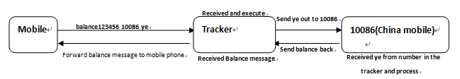

Remote immobilizing (Model B)
    - Immediate execution way
SMS command: quickstop+password
Tracker response: quickstop OK
Example: quickstop123456
Tracker will immobilize the vehicle immediately.
    - Remote immobilizing
SMS command: stop+password, Tracker response: Stop engine succeed
Example: stop123456
When receiving STOP command, tracker will check speed and reply"it will be executed after speed less than 20KM/H". If speed is higher than 20KM/H, and delay executing this command until the speed is less than 20KM/H.
    - Remote fuel resume
SMS command: resume+password, Tracker response: Resume engine Succeed
Example: resume123456
This means tracker will now resume the fuel & power supply.

Configure times of alarm
The times of sos, power alarm sending can be set.
Send once by default.
SMS command: xtime+password+times value
Tracker response: xtime ok!
Example: xtime123456 005 (It means to send alarm 5 times.)
Note: The times value must be 3 digits

Alarms
    - Low battery alarm
This feature is activated by default, when the battery voltage is close to 3.55V, tracker will send message “low battery + latitude & longitude” to authorized numbers for 2 times at 15 minutes interval.
SMS command to deactivate: lowbattery+password+space+off
Tracker response: lowbattery off ok
Example: lowbattery123456 off
SMS command to activate: lowbattery+password+space+on
Tracker response: lowbattery on ok
Example: lowbattery123456 on
    - Power disconnection alarm (Model B)
This feature deactivated by default. Tracker will send “Power alarm+latitude& longitude” to authorized numbers when it is activated and external power disconnected.You can receive alarm notifications on the app at the same time.
SMS command to deactivate: extpower +password+space+off
Tracker response: extpower off ok
Example: expower123456 off
SMS command to activate: extpower +password+space+on
Tracker response: extpower on ok
Example: expower123456 on
    - Blind area alarm
This feature is deactivated by default, tracker will send SMS notification “No gps+latitude& longitude of the last know position.” to authorized numbers if lost fix to GPS satellites.
SMS command to activate: gpssignal +password+space+on
Tracker response: gpssignal on ok
Example: gpssignal123456 on
SMS command to deactivate: gpssignal +password+space+off
Tracker response: gpssignal off ok
Example: gpssignal123456 off
    - SOS alarm (Model B)
Press SOS button for 3 seconds, tracker will send SMS notification "Help me+latitude& longitude" to all the authorized numbers.
    - Geo-fence
The Geo-fence feature creates a virtual fence. When the tracker moves out of this virtual fence, SMS notification "stockade!+latitude &longitude" will be sent to the authorized numbers when SMS mode. Geo-fence alarm will be sent to Web when gprs mode.
command to activate: stockade+password+space+latitude, longitude; latitude, longitude
Tracker response: stockade ok!
Example: stockade123456 22.554459, 113.903981; 22.553002, 113.909378
Note: The first latitude & longitude is coordinate of the top left corner of the Geo-fence, and the second latitude & longitude is the coordinate of the bottom right corner.
Command to deactivate: nostockade+password
Example: nostockade123456
    - Movement alarm
When the device stays in one place for 3-10 minutes and confirms that there is a GPS signal, you can send the SMS command "move+password+space+0200" to the device (assuming a range of 200 meters, maximum support four digits, unit: meters), the device Will reply "move ok!". Once the device is out of range, the device will reply the message "move + latitude and longitude" to the authorized number. (The default distance of the device is 200 meters,)
Cancel the setting: Send SMS "nomove+password" to cancel this function setting.
    - Over speed alarm
Send SMS command "speed+password+space+080" to the device (assuming the speed is 80km/h), then the device will reply "speed ok!". When the device runs over 80km/h, the device will send the message " speed+080!+latitude and longitude" to the authorization number. Over speed alarm SMS mode only sends a text message once within 3 minutes, GPRS mode only send once within 3 seconds; the siren sounds for one second when speeding.
Cancel the setting: Send SMS "nospeed+password" to cancel this function setting.
Note: The recommended speed should not be less than 30km/h.If the speed is set lower than this you may get a false alarm due to GPS inaccuracy.
    - Acceleration Sensor Alarm
There is a built-in three axis acceleration sensor in the tracker to detect the movement, tilt and shock. Tracker will send “Sensor alarm + latitude / longitude” to authorized numbers when vibrate
      - SMS command to activate: shock+password, Tracker response: Shock is activated
      - SMS command to deactivate: noshock+password, Tracker response: noshock ok
      - Sensor’s sensitivity configuration(First level is default)
First level: Alarm will be triggered by slight vibration.
SMS command: sensitivity+password+space+1
Tracker response: sensitivity ok
Second level: Alarm will be triggered by medium vibration.
SMS command: sensitivity+password+space+2
Tracker response: sensitivity ok
Third level: Alarm will be triggered by severe vibration.
SMS command: sensitivity+password+space+3
Tracker response: sensitivity ok

Check Status
SMS command: check+password
Reply: Battery, GPS signal, GSM signal, GPRS, APN, UP, IP, Port etc
Example: check123456
Tracker response:
Battery: 100%
GPRS: ON/OFF
GPS: OK/NO GPS
GSM Signal: 1-32 (The higher, the better)
APN: cmnet
IP: 104.250.138.146
PORT: 9000
Arm: OFF/ON

Check IMEI
SMS command: imei+password
Tracker response: xxxxxxxxxxxxxxx (A 15 digits IMEI of your device)
Example: imei123456

Local time setting
Tracker works in the local time zone by default. If you find that the time zone is incorrect, you can configure the time zone
SMS command: time+space+zone+password+space+time zone value
Tracker responds: time ok
Example: time zone123456 8

Reset Hardware
SMS Command: reset+password
Tracker Response: reset ok
Example: reset123456

Configure parameters by USB
Using the USB cable to connect the tracker to a computer and open the configuration file with notepad, and then manually change the parameters and settings according to the tips.
Note: You must enter the correct password of the tracker in the old password field every time when changing the settings; otherwise, the changes won’t be successful.

TCP / UDP switch
SMS command to switch to TCP mode: GPRS+password,0,0 (TCP mode is the default one)
SMS command to switch to UDP mode: GPRS+password,1,1
Tracker response: GPRS OK!
Example: GPRS123456,0,0
GPRS123456,1,1

SMS mode
Switch to SMS mode will disconnect the GPRS connection for live tracking.
SMS command: SMS+password
Tracker response: SMS OK! ( It means it has been switched to SMS mode.)
Example: SMS123456

Configure SMS monitoring center number
SMS command: centernum+password+space+phone number
Tracker response: centernum ok
After the SMS monitoring center number is successfully set, the SMS reported by the positioning strategy will be sent to this number.
If the monitoring center number needs to receive the alarm notification message, please set this number as an authorized number too.
Cancel SMS monitoring center number
SMS command: nocenternum+password
Tracker response: nocenternum ok
Example: nocenternum123456

Configure GPRS heartbeat package interval
The default heartbeat interval to keep GPRS connection alive is 100 seconds; you can change it if necessary, but please be kindly informed that if the time interval is too long, it may cause GPRS disconnection.
SMS command: heartbeat+password+space+time interval
Tracker response: heartbeat ok
Example: heartbeat123456 120

Note: (123456 means tracker’s password, 120 means the interval.)
The minimum interval is 60 seconds, and tracker will continue to send heartbeat every 60 seconds if you configure it less than 60 seconds.

Initialization
If the tracker cannot work properly, you can send command to initialize it to return to default factory settings.
SMS command: begin+password
Tracker response: begin ok
Example: begin123456

Cautions
Please be sure to follow when using:
1. Keep the tracker used in a dry environment. The humid environment can easily damage internal circuits.
2. Please do not put it in a dusty environment.
3. Do not put the tracker in overheated or overcooled places.
4. Handle carefully. Don’t vibrate or shake it violently.
5. Please clean with a dry cloth, do not use chemicals and detergents.
6. Please do not paint the device; this may lead to internal circuit failure.
7. Do not disassemble the device.
8. Please read the user manual carefully before installation and operation, and understand voltage range. Otherwise, it won’t work properly or damage the tracker.

Troubleshooting

Faults | Solution
Fail to turn on | - Please check if the power wiring is correct?  - Please check if the power voltage is correct?
No GSM signal | - Check whether the SIM card is put in place.  - Whether the SIM card is a GSM network SIM card.  - Don’t turn on the PIN code.  - Call forwarding cannot be opened.
No GPS signal | The device needs to be in an unobstructed position to ensure that it can receive GPS signals normally.
No response for SMS command | - No credit on SIM card.  - The password is incorrect or the format of the SMS command is incorrect.
No response for a call/No alarm notification message | - Did you have set up the authorized phone number?  - If authorized number exists, did you make the call from an authorized phone number?  - The format of the phone number is incorrect.
Fail to stop engine | Please check whether the engine stop wiring connected correctly?  Please check whether the speed is higher than the speed to execute the stop command when using Delay execution way?

